**Frontend Development with React.js**

**Project Documentation: Navigate the News landscape**

**1. Introduction**

Project Title:

Bangtan News

**Team Members and Roles:**

**Team Leader**: Selshiya X

**Team Members:**

* **Santhiya S**
* **Sathya R**
* **Shruthi Laya B**

**2. Project Overview**

**Purpose:**

**Bangtan News is a web application aimed at improving the news consumption experience by delivering a smooth and interactive interface. It compiles news from various sources, organizes it into categories, and includes an advanced search feature for effortless navigation.**

**Features:**

* **News is aggregated from various API sources.**
* **The interface is designed to be intuitive and easy to use.**
* **It offers robust search capabilities.**
* **The design is visually appealing, with news presented in organized categories.**
* **Users can subscribe to receive daily news updates.**

**3. Architecture**

**Component Structure:**

The project follows a modular React.js component structure:

* The Pages Folder houses various application pages.
* The Components Folder holds reusable user interface elements.
* The Context Folder oversees the application state with the help of the Context API.
* The Styles Folder contains CSS files used for styling the application..

**State Management:**

Utilizes the Context API for managing global state as well as handling local state within individual components.

**Routing:**

Implemented using React Router Dom for smooth navigation between pages.

**4. Setup Instructions**

**Prerequisites:**

Node.js and npm (Download: <https://nodejs.org/en/download>)

Git for version control (Download: <https://git-scm.com/downloads>)

**Installation:**

1. Clone the repository:  
 git clone repository link  
 cd nexus-news

2. Install dependencies:  
 npm install

3. Start the development server:  
 npm start

## 5. Folder Structure

bangtan-news/  
│── src/  
│ ├── components/   
│ ├── context/   
│ ├── pages/   
│ ├── styles/   
│── public/  
│── package.json  
│── README.md

**6. Running the Application**

**Run the frontend server:**  
  
npm start  
  
Access the app at http://localhost:3000

**7. Component Documentation**

* Navbar: Displays navigation links.
* Hero Section: Highlights trending news.
* NewsCard: Displays individual news articles.

**8. State Management**

* Global State: Managed using Context API.
* Local State: Controlled within individual components.

**9. User Interface**

Screenshots:

* Hero section showcasing trending news

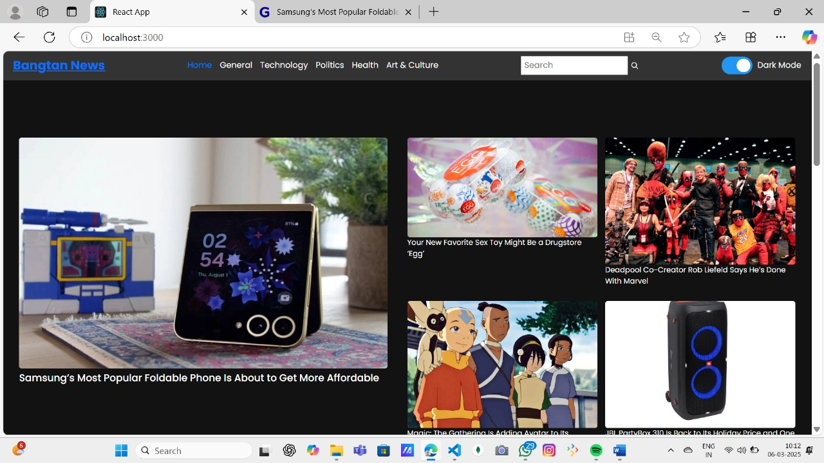

* Category search results page.

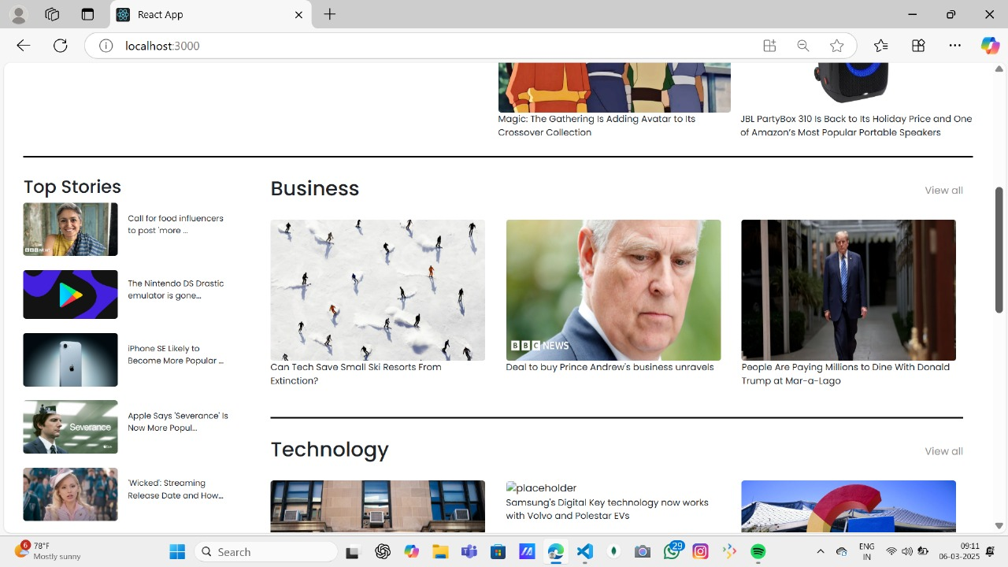

**10. Styling**

* Bootstrap/Tailwind CSS used for UI design.
* React Icons for visual elements.

**11. Testing**

* Jest & React Testing Library used for unit and integration testing.

**12. Screenshots or Demo**

* **Hero component**



**Redirected component**

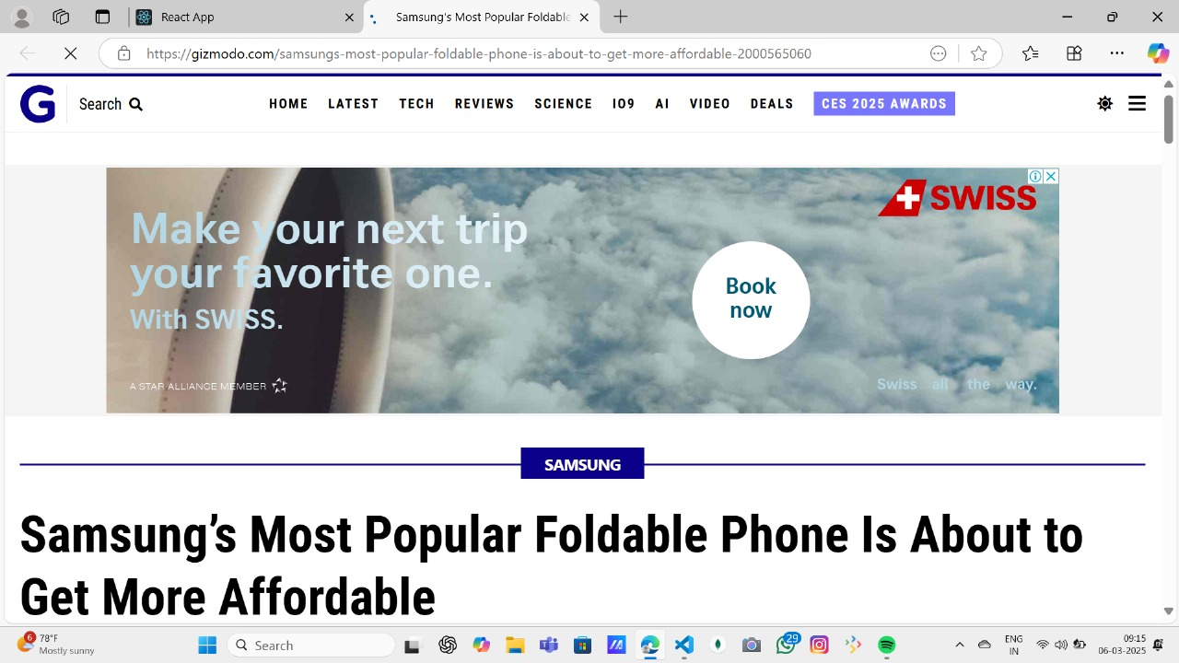

* **Category component**

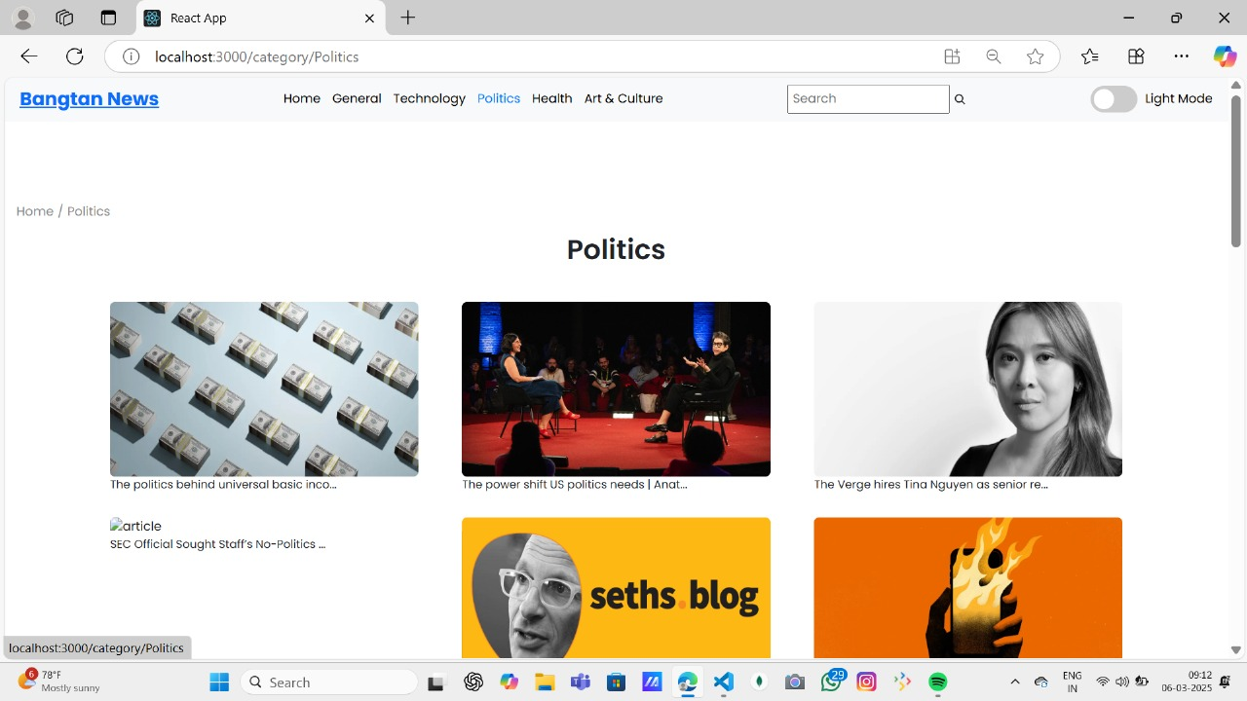

* **News Letter**

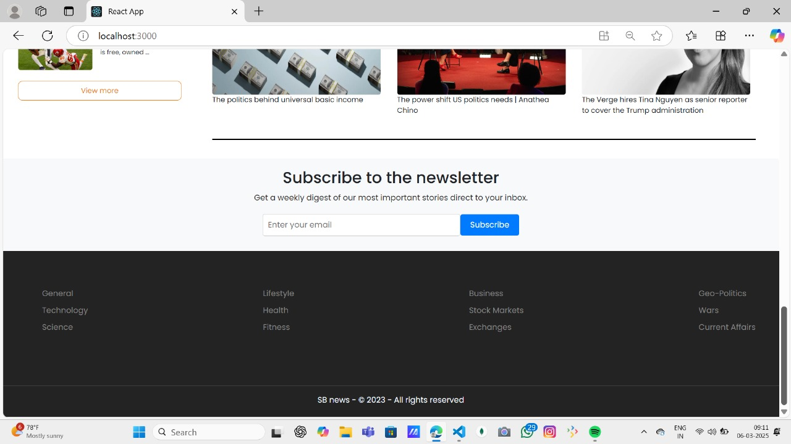

Live Demo:

[https://drive.google.com/file/d/1npKT9xbdWpH6KnRRdu_VSqrJk7YywiSU/view](%20https://drive.google.com/file/d/1npKT9xbdWpH6KnRRdu_VSqrJk7YywiSU/view)

**13. Known Issues**

* Certain API calls are subject to rate limits, which may affect performance.
* UI enhancements are required to improve mobile responsiveness.
* Occasional delays in push notifications delivery.
* Dark mode may not apply correctly to all UI elements.
* Some third-party integrations may experience intermittent failures.

**14. Future Enhancements**

* Secure user login and authentication
* Real-time push alerts and notifications
* Option to switch between light and dark mode
* Seamless integration with third-party servicesUser-friendly and intuitive interface

**15. Code Repository**

Use the source code link:

[https://drive.google.com/drive/folders/1nyKDEjeiQv0VYL3M09tZu8tGlFNNP0OK?usp=sharing](https://drive.google.com/drive/folders/1nyKDEjeiQv0VYL3M09tZu8tGlFNNP0OK?usp=sharing%20%20%20%20%20%20%20%20%20%20%20%20%20%20%20%20%20%20)

GiHhub link:

<https://github.com/Selshiyabca/News_App>

Demo link: <https://drive.google.com/file/d/1hPsq2h7dRm22do7C34Elo9J741AP3nCu/view?usp=sharing7z/view>